# User Manual

## Introduction

Library Path Search System (LPSS) system is a system that can help you find the shortest way to get those books you want. For a Junior Librarian, it will be very practical to reduce the work of returning the books back to the shelves. This manual is used for general user and staffs of the library.

## Authority

C:\Users\Sidney\Desktop\UserMaunal\NOUSEFORGENERALUSER.png

As you can see this is this is main navigation bar of the website. Different type of people has different authority to enter those pages.

If a user clicks on the page without authority, the page will just link to Home Page.

|  |  |  |  |  |  |
| --- | --- | --- | --- | --- | --- |
| Pages | General user | Junior Librarian | Senior Librarian | Database Administer | Curator |
| Home | YES | YES | YES | YES | YES |
| Personal | YES | YES | YES | YES | YES |
| Search | YES | YES | YES | YES | YES |
| People | No | YES | YES | YES | YES |
| Books | No | No | YES | YES | YES |
| Maps | No | No | No | YES | YES |
| About us | YES | YES | YES | YES | YES |

## Manage Personal Information

### Personal Webpage Introduction

Click  on the main navigation bar, this will lead you to the personal page.

In this web, you can get information about how to **change password**, **view and modify favorite list**, **view borrowed list and to-do list**.

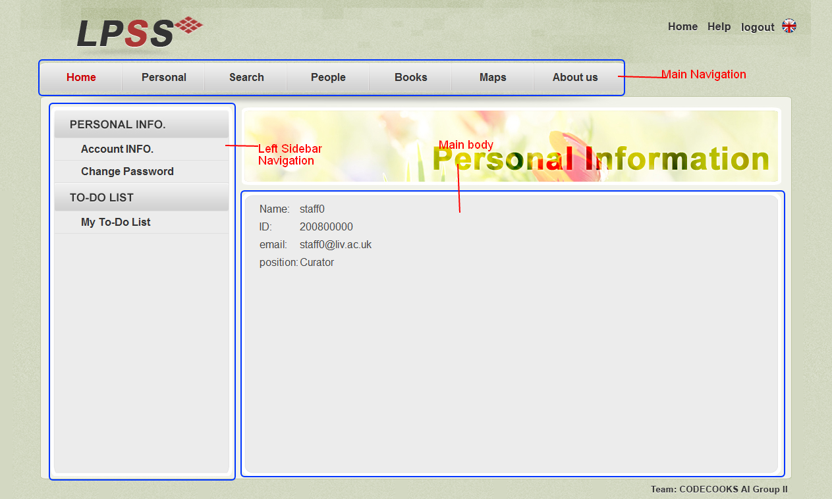

There is a little different between general user and staff.

|  |  |
| --- | --- |
| General User | Staff |
| C:\Users\Sidney\Desktop\UserMaunal\GeneralUserNavigation.png | C:\Users\Sidney\Desktop\UserMaunal\StaffNavigation.png |

|  |  |
| --- | --- |
| If you are a general user, you can do | If you are a staff, you can do |
| 1. View personal information 2. Change password 3. View Borrowed list 4. View favorite list | 1. View personal information 2. Change password 3. View and modify to-do-list |

Note: Modify favorite list in not in this page, modify favorite list will be mentioned on search for shortest path section.

## Search for shortest path

### Search Webpage Introduction

Click  on the main navigation bar, this will lead you to the Search page. On this page a user could **search for a book** and get the **shortest path** of those books that you want.

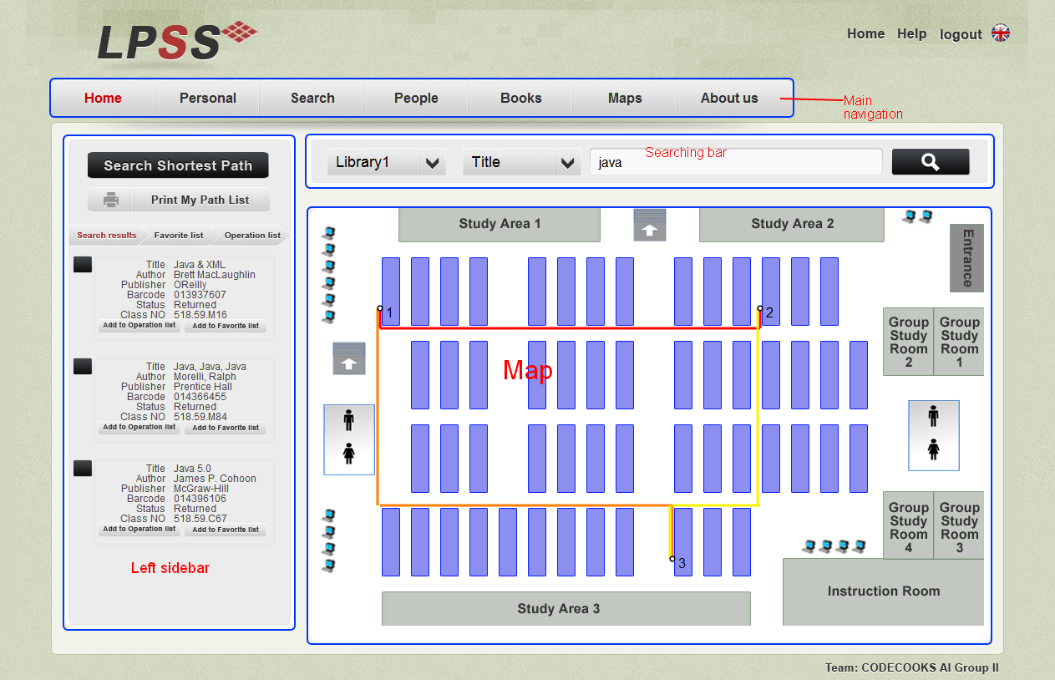

Here is a searching Bar:



**Search for books steps:**

1. Choose the library: The library name that your books would be.
2. Choose search category: This could be book title, author or barcode.
3. Enter the key word: Not case sensitive

Simple click on the search icon on the right, the result will be displayed at the left of the web page.

**Get shortest path**

Just simple add the book to operation list. Then the path will be displayed on the map area.

**Display**



Click on the tabs to see the search result, favorite list or operation list.

In the favorite list, the book could be modified like add, drop or add to operation list.

## Staff Management

All the staff could search for all users of LPSS, but only curator could manage staff.

### People Webpage Introduction

Click  on the main navigation bar, this will lead you to the staff management page. In this web page a manager could **view all users** and **manage staff**.

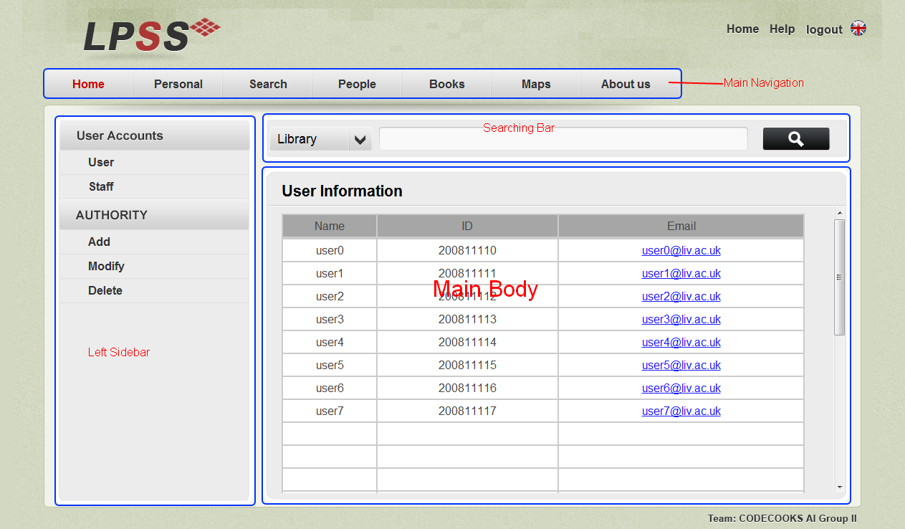There is little different between curator and other staff on left sidebar navigation.

|  |  |
| --- | --- |
| Curator | Other staff |
| C:\Users\Sidney\Desktop\UserMaunal\CuratorPeople.png |  |

So only the curator has the authority to manage people.

### Search for people



Using this searching bar on this page

1. Choose people’s type such as User or Staff.
2. Choose a search category Name, ID or Status.

The just click on search icon, the result will be displayed bellow the search bar.

### Manage staff

There are three type operations that could be used to modify staff: **add**, **modify** and **delete**.

#### Add

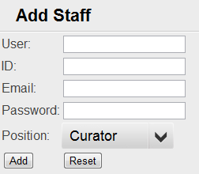

If and only if the conditions bellow are satisfied the staff could be add:

1. User name could not be the same with other staff
2. User ID could not be same with other staff

The reset button is to clean everything entered.

#### Modify

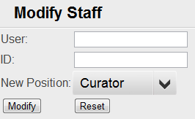

If and only if the following conditions are satisfied, then the staff’s position could be changed.

1. The user name entered should exist.
2. The ID of the user must be the correct

The reset button is to clean everything entered.

#### Delete

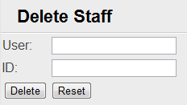

If and only if the following conditions are satisfied, then the staff could be deleted.

1. The user name entered should exist.
2. The ID of the user must be the correct

The reset button is to clean everything entered.

## Add book

Only Senior Librarian and Database Administer and curator could add a book to the database.

### Book Webpage Introduction

Click  on the main navigation bar, this will lead you to the book adding page. Senior Librarian can use this page to **add books** to the database.

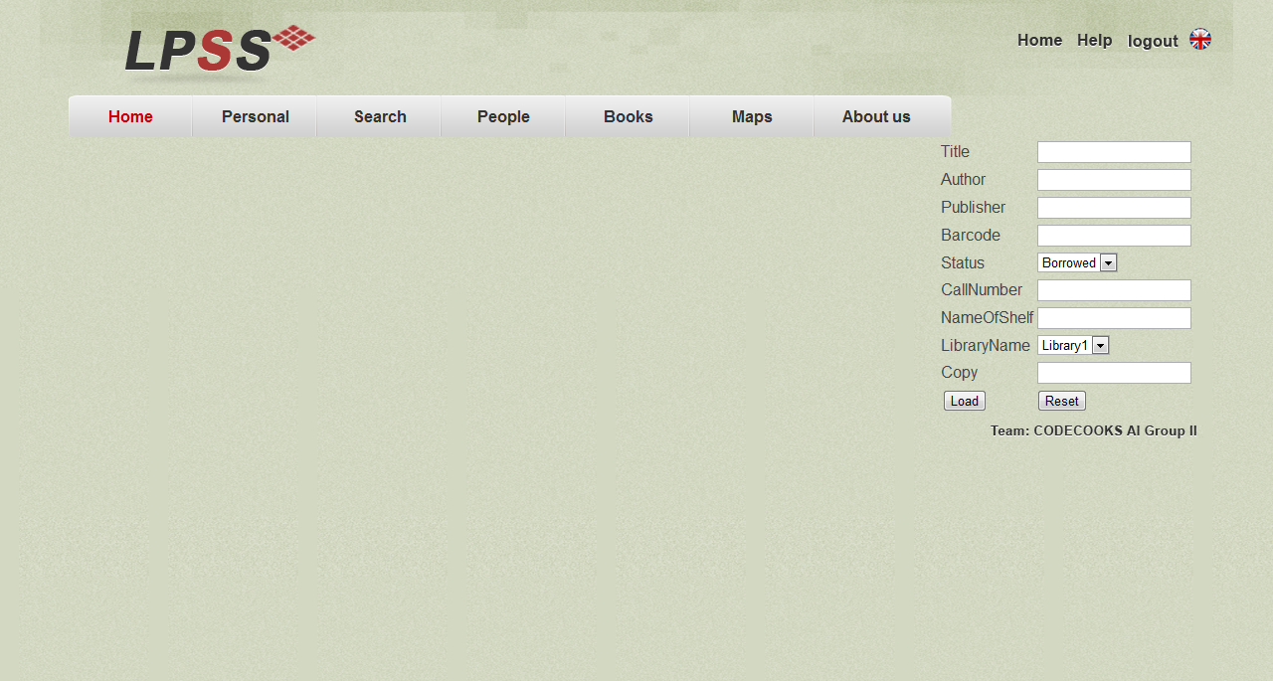

Senior Librarian can use this page to add books to the database, if and only if the barcode of the book is not the same with other books, then the book could be added.

## Edit map

Only the curator and database administer could edit a map.

### Map Webpage Introduction

Click  on the main navigation bar, this will lead you to the map edit page. Database administer can use this page to **edit maps** of the database.

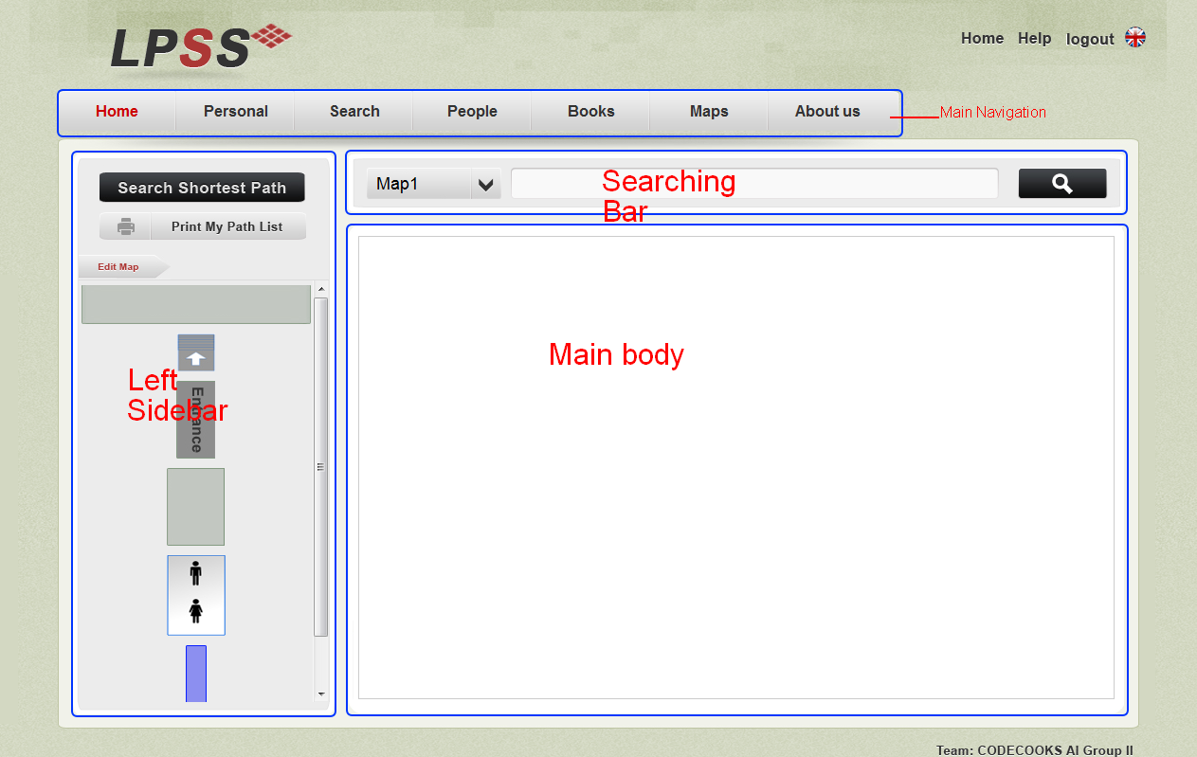

**Search for library map**



This searching bar is used to search for map of a particular library.

### Edit and save map

There is some stuff that a library may have in the left sidebar.

**Add stuff to the map**: Simple drag the stuff to the map.

**Draw map**: In the main body of map page, hold the left button of mouse and move.

**Note:** As this function in implemented using HTML5, it can only be used on the browser which supports HTML5 such as chrome.

## About us

Click  on the main navigation bar, this will lead you to webpage which contains the information about us.

Click the name on the left side bar navigator, then you can email us.